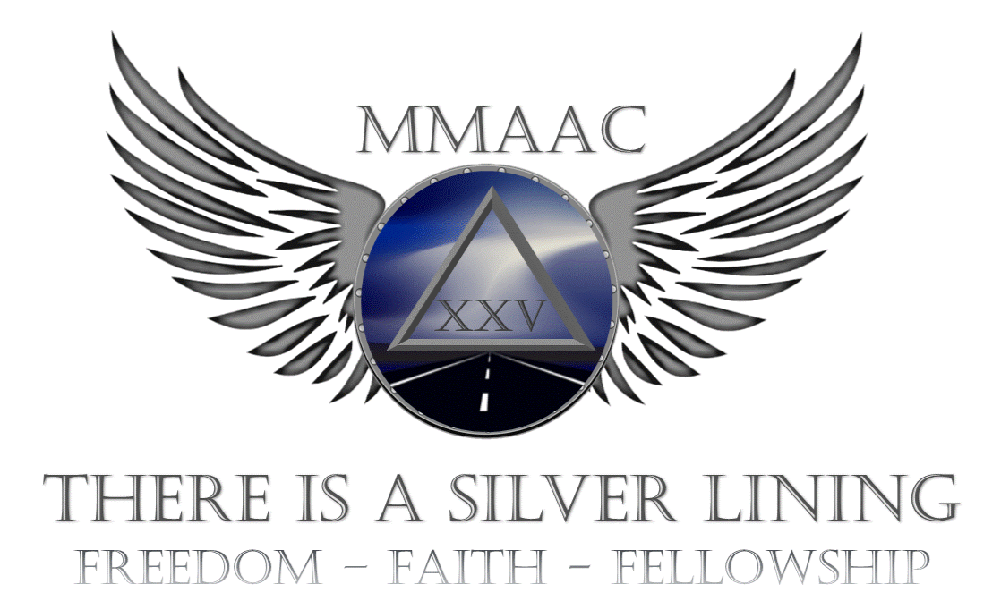

**25th Annual MMAAC May 30th, 31st & June 1st 2025**

Midwest Motorcycle AA Convention ** Sponsored by Individual AA Members** Green Lake Conference Center, Green Lake, WI

*REGISTRATION CONTACTS:*  Orlando C. (262) 901-5892 & Matt M. (920) 691-6500

AA & Al-Anon Speakers:

AA-Bobby C., Philadelphia, PA --- AA-Barefoot Scott, Grand Rapids, MI

AA-Emily N., Waukesha, WI --- AA-Jeff G., Dallas TX

Al-Anon: Sarah L. Waukesha, WI

Exciting AA & Al-Anon Speakers**,** Camping (primitive & w/ hook-ups), Pulled Pork Dinner Sat. evening, Alkathons**,** Fellowship, Motorcycle Rodeo w/ Field Events for non-riders**,** Campfire Meetings**,** Organized Runs**,** Entertainment, Family Friendly activities all weekend**,** Hospitality Area**,** Merchandise & Vendors.

*On-Site Accommodations include: Lodges, Cabins, Hotels, Camping, & Lake Houses all on site & Meal packages available: inquire when setting up lodging. Fishing, Boating, Hiking, Swimming, Golf, Volleyball & more.*

Contact: Green Lake Conference Center, W2511 State Road 23, Green

Lake, WI (920) 294-3323 [www.GLCC.org](http://www.GLCC.org)

Pre-registration: $ 20.00 (Postmarked by May 10th 2025) On-Site registration: $ 25.00 Children 0-17 years: FREE ONE- DAY- PASS: $15.00

**ACCOMMODATIONS & REGISTRATION are SEPARATE COSTS**

Visit us at [WWW.MMAAC.org](http://WWW.MMAAC.org), Register, Souvenirs & other exciting convention news !!

For more Info: Jodi S. 815-703-6071 or Elizabeth 262-705-4220

MMAAC 25 Registration Form

please print clearly**……**PLEASE FILL OUT COMPLETELY

Use 1 form per person 13 years and older (copies OK) and mail to:

PO BOX 2211, Waukesha, WI 53187-2211

Name: __________________________________ Name on Badge _____________________________

Address: _______________________________________ A.A.______ AL-Anon ______Other_______

City, State, Zip:__________________________________ Sobriety date: _______________________

E-mail Address: _________________________________ Phone number: ­­­­­­­­­______________________

RECEIVE YOUR INFORMATION BY E-MAIL? **IF YES PLEASE CHECK HERE ___________**

Would you like to chair an Alkathon meeting? Yes___ No___ if yes, phone#______-_____-_________

**Would you be willing to volunteer? Yes_____ No _____ if yes, phone# _____-_____-________**

Hearing impaired or other special needs? (specify) __________________________________________

Number of children under 13 accompanying you ___________ age(s)___________________________

Pre-Registration: $20.00______ $

**\*\*\*PORK DINNERS MUST BE RECEIVED WITH REGISTRATIONS POSTMARKED BY May 10th, 2025. \*\*\*\***

A LIMITED NUMBER OF DINNERS MAY BE AVAILABLE AT THE CONVENTION

# of Pork dinners (Adult): $15.00 ______ $

# of Pork Dinners

(Child-10 OR UNDER): $7.00______ $

Amount of apparel items _______ $

Total Amount paid: $ _______ **NO CONFIRMATION OF YOUR REGISTRATION WILL BE SENT**

**CONFERENCE SHIRTS: (Please look at website to see shirts)**

** Short Sleeve Tee (Lg. logo on front w/ previous years themes on back) Black or Blue / S to 2XL: $20.00

** Long Sleeve Tee (Lg. logo on front w/ previous years themes on back & MMAAC down sleeve) Black or Blue / Small to 2XL: $25.00

**Pullover Hooded Sweatshirt (Lg. logo on front w/ previous years themes on back / Black or Blue / Small to 2XL: $ 35.00

**\*\*\*\*ANY VARIATION OF SHIRT YOU WANT CAN POSSIBLY BE ORDERED, JUST CALL. ANY COLOR—ANY SHIRT OR JACKET—JUST ASK—MUST BE PRE-PAID & NO RETURNS, NO REFUNDS - Call John at (779)770-7127\*\*\*\***

***PREORDERS MUST BE RECEIVED WITH REGISTRATIONS POSTMARKED BY May 10TH , 2025***

***ORDERS RECEIVED AFTER MAY 10TH , 2025 MAY NOT BE AVAILABLE AND WILL   
BE MAILED SHORTLY AFTER THE CONFERENCE IF SIZE AND PREFERENCE ARE NOT AVAILABLE***

***ONLY A **VERY** LIMITED SUPPLY OF SHIRTS WILL BE AVAILABLE AT THE CONVENTION***



<https://mmaac.org/register/>



<https://mmaac.org/register/mmaac-2025-shirts/>